Pickles Pond

Booking Process
- All bookings to be made at lease 24hrs in advance via Phone (01277212784 opt1) or email enquiries@thriftwood.org.uk
- A swim must be booked or will be allocated for you.
- Payment must be made by Card at time of booking
- A gate code will be issued for the day of fishing, valid for one day only
- £10 per fisherman for max 2 rods
- NO GUESTS
- No Under 16’s without adult supervision
- No Toilet facilities available
- Do not book if feeling unwell, or have symptoms of Covid-19 or if anyone in your house has symptoms.

Arrival Process
- Fishermen to use issued code on key pad, Don’t forget the #
- Fishermen to drive directly to Pickles Pond
- Park in carpark
- Use signs to go to booked swim.
- Be respectful of other fishermen
- Swims should be 15m apart where possible
- Fishing time is from 8am to 9pm
- No Keep nets, barbed hooks, bait boats
- NO FIRES
- NO ALCOHOL
- ALL Rubbish to be taken home.

Please do not move swims
If you are found to be in breach of rules or Government guidelines you will be asked to leave and not allows back. No refunds will be given.
Please respect the fishery, other fishermen and the Thriftwood Staff & Volunteers.

Swims
Swim 1 Swim 2
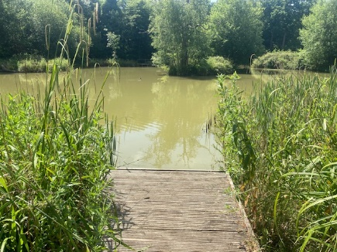
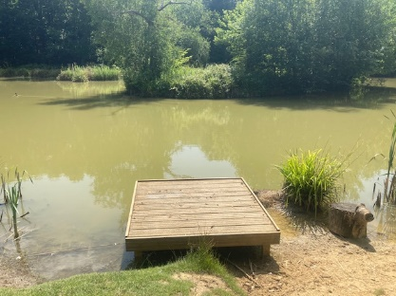

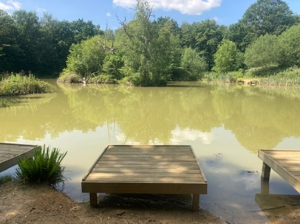
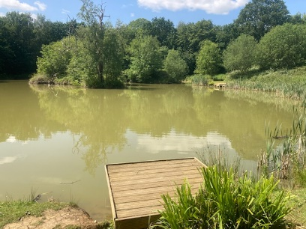
Swim 3 Swim 4

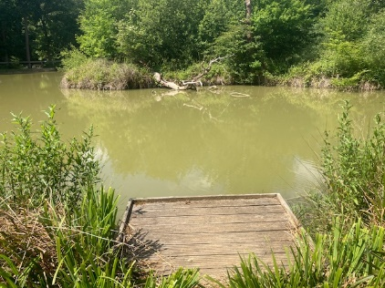
Swim 5 Swim 6
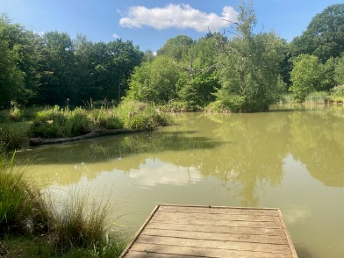

Swim 7 Swim 8
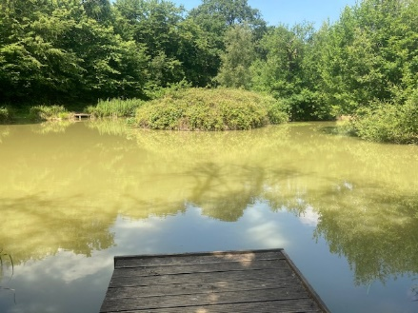
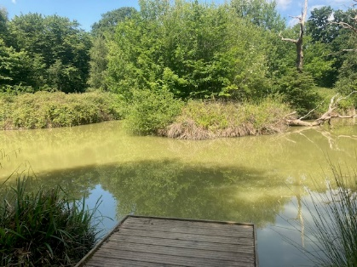

Swim 9 Swim 10
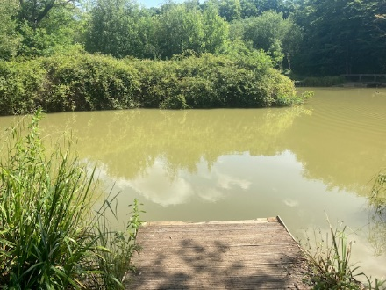
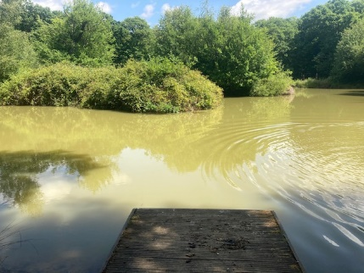

Pickles Pond Swim Map

