Pickles Pond/

Booking Process
- All bookings to be made 24hrs in advance via Phone (01277 212784 opt1) or email enquiries@thriftwood.org.uk
- A swim must be requested or will be allocated for you.
- Payment must be made via Bank Transfer or Card at time of booking
- A gate code will be issued for the day of fishing, valid for one day only
- £10 per fisherman for max 2 rods. One Fisherman per swim
- NO GUESTS (Paying or non-paying)
- No under 16’s without adult supervision
- NO TOILET FACILITIES AVAILABLE
- Do not book if feeling unwell, or have symptoms of Covid-19 or if anyone in your house has symptoms.

Arrival Process
- Do not arrive if feeling unwell, or have symptoms of Covid-19 or if anyone in your house has symptoms.
- Fishermen should arrive on their own unless they can prove they are travelling with someone they live with
- Fishermen to use hand sanitizer before using entrance/ exit key pad
- Fishermen to drive directly to Pickles Pond
- Park in carpark keeping 2m from other fishermen
- Use signs to go to booked swim.
- Keep 2m from other fishermen while fishing and while making your way to and from your allocated swim.
- Anglers may fish with one person not from their household but maintaining 2m distance.
- Family units may share swims / be closer than 2m.
- Keep to swim platform, leave paths clear.
- Fishing time is reduced from 8am to 9pm.
- Bring disposable gloves and sanitizer and use when touching surfaces others may come into contact with.
- NO FIRES.
- NO ALCOHOL.
- NO TOILETS
- ALL Rubbish to be taken home.
- A ROD LICENCE IS REQUIRED FOR ALL OVER THE AGE OF 12

Please do not move from booked swim
A drone patrol will randomly check the lake
If you are found to be in breach of rules or Government guidelines you will be asked to leave and not allowed back. No refunds will be given. Please respect the fishery, other fishermen and the Thriftwood Staff & Volunteers.

If you become unwell after visiting the lake, please inform the campsite on the number above.

Swims
Swim 1 Swim 2
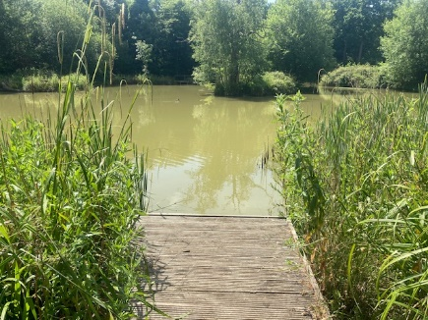
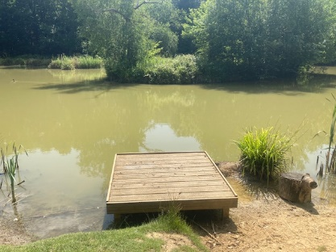

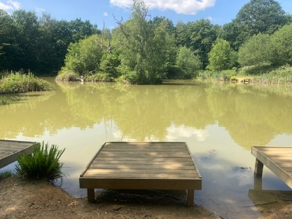
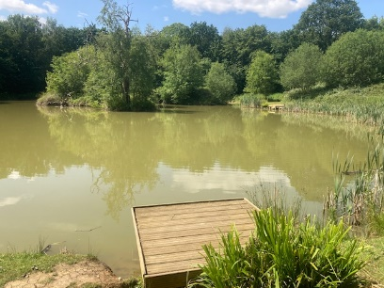
Swim 3 Swim 4

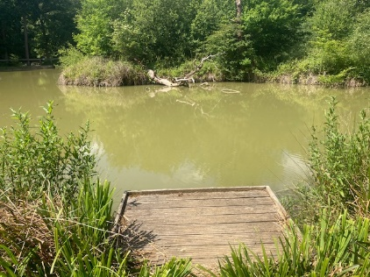
Swim 5 Swim 6
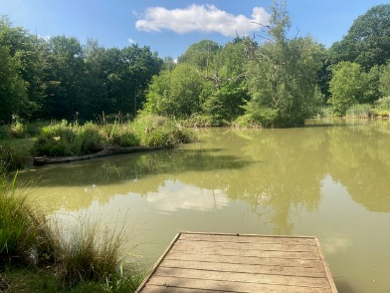

Swim 7 Swim 8
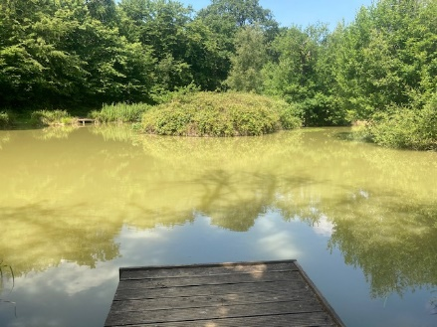
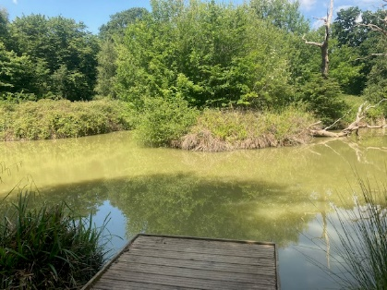

Swim 9 Swim 10
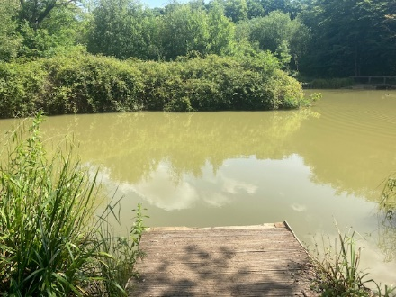
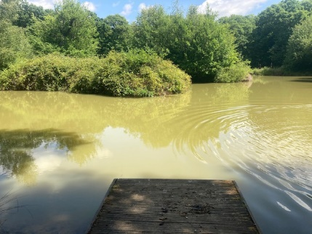

Pickles Pond Swim Map

